Name ___________________________________________

Math 107

Practice Test 3

DIRECTIONS:

Complete the following practice test, showing all your work on another sheet of paper. Do not use your book or any other materials to help you. This will give you an idea if you are ready for the Post Test. After you have completed this Practice Test, score it and ask your Instructor about any questions you cannot figure out.

If you feel you are not ready for the Test, you may wish to practice more with the practice tests found in Connect Math.

When you are ready to test, show this completed Practice Test to your Instructor.

1. Plot the point (6, -5)
2. Plot the point (0,-4)
3. The income level defining the poverty line for an individual is given for select years between 1970 and 1995. Let x represent the number of years since 1970. Let y represent the income defining the poverty level.

(0,3200), (5, 5050), (10,6900), (15, 8750), (20,10600), (25, 12450)

Intrepret the meaning of the ordered pair (0, 3200). Write your answer in sentence form.

1. Determine if  is a solution to the equation 
2. Graph the line: 
3. Find the x and y intercepts of 
4. Identify as a horizontal or vertical line.
5. Graph the line 
6. Find the x and y intercepts of 
7. Determine the slope by using the slope formula and any two points on the line.

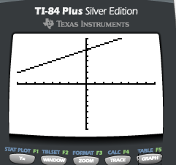

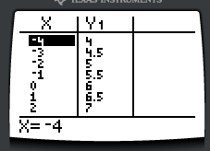

11. Determine the slope the line below.



1. Find the slope of the line that passes through and 
2. Find the slope of the line that passes through the points  and . Round your answer to two decimal places, if needed.
3. Round your answer to the nearest tenth.

In the year 1989, there were 16 thousand female inmates in federal and state prisons. By 2005, the number had increased to 93 thousand.

Let x represent the years and let y represent the number of prisoners (in thousands). Using the ordered pairs and , find the slope of the line.

1. Round your answer to the nearest tenth.

In the year 1990, there were 13 thousand female inmates in federal and state prisons. By 2005, the number increased to 91 thousand.

Let x represent the year, and y represent the number of prisoners (in thousands). Interpret the slope in the context of this problem.

The number of female inmates increased by _________ thousand in _______

Years.

1. In 1982, a delivery service charged $0.23 for the first class letters and cards up to 1 oz. by 2008, the price had increased to $0.51. In the graph below, x represents the year, and y represents the cost for 1 oz of first class postage.



Years

Rate $

(1982,0.23)

(2008,0.51)

1. Determine the slope of the line. Round to three decimal places.
2. State the slope and interpret the meaning of the slope in the context of this problem. Write your answer in sentence form.
3. Identify the slope and y-intercept of 
4. Graph 
5. Write  in slope-intercept form and graph the line.
6. Are the lines  and  parallel?
7. Write an equation of the line having a slope of 7 and y intercept of . Write your answer in slope-intercept form.
8. Use the point-slope formula to find an equation of the line having a slope of 5 and passing through the point . Write your answer in slope-intercept form.
9. Find an equation for the line through the given points. Write the final answer in slope-intercept form.

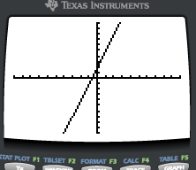

(-2,-4)

(1,5)

1. Use the point-slope formula to write an equation of a line that passes through the point  and is perpendicular to the line 
2. Write an equation of the line that passes through the point  and is perpendicular to the line y = 2.
3. The average daily temperature in January for cities along the eastern seaboard of two countries generally decreases for cities farther to the north. A city’s latitude in the northern hemisphere is a measure of how far north it is on the globe. The average temperature, y (measured in degrees Fahrenheit) can be described by the equation  where x is the latitude of the city. Use the equation to predict the average daily temperature in January for a city whose latitude is 38.8 degrees N. Round all answers to one decimal place.
4. The average daily temperature in January for cities along the eastern seaboard of two countries generally decreases for cities farther north. A city’s latitude in the northern hemisphere is a measure of how far north it is on the globe. The average temperature, y, (measured in degrees Fahrenheit) can be described by the equation  where x is the latitude of the city. What is the slope of the line? Interpret the meaning of the slope in terms of the latitude and temperature. Write your answer in sentence form.
5. The graph below shows the average height for boys based on age. Let x represent the boy’s age, and y represent his height in inches.

Average Height of Boys Based on Age

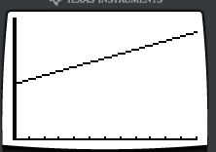

(2, 37)

(8,52)

Height (in)

Age (yrs)

1. Find a linear equation that represents the height of a boy versus his age. Write your answer in slope-intercept form with numeric values rounded to two decimal places, if necessary.
2. Use the linear equation found to predict the average height of a 6 year old boy..

1. Determine the domain and range of the relation 
2. Determine if the relation is a function.

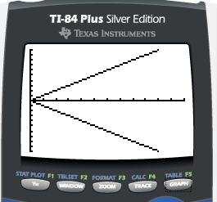

1. Evaluate , find 
2. In the absence of air resistance, the speed, s (in feet per second: ft/sec), of an object in free fall is a function of the number of seconds t, after it was dropped. . Find , and interpret the meaning of this function. Write your answer as a sentence.
3. In the absence of air resistance, the speed, s (in feet per second: ft/sec), of an object in free fall is a function of the number of seconds t, after it was dropped. . A ball dropped from a building falls approximately 8.3 sec. How fast was the ball going when it hit the ground?

Practice Test 3

Answer Key

1.

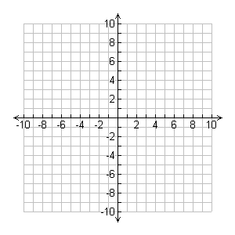

2.



3. In the year 1970, the income defining the poverty level was $3200.

4. Yes

5.



6. x intercept (-12,0); y intercept (0,8)

7. Vertical

8.



9. x – intercept (5, 0), no y-intercept

10. slope is 

11. slope is 0

12. slope is 

13. 3.06

14. slope is 

15. The number of female inmates increased by 26 thousand in 5 years, or approximately 5.2 thousands inmates per year.

16. Slope is 0.011. The slope of 0.011 means that the postage increased by about $0.011 per year during this time.

17. Slope is , y-intercept is (0,0)

18.



19.



20. False, the lines are neither parallel or perpendicular

21. 

22. 

23. 

24. 

25. 

26. 32.7 

27. Slope is -2.390. The average temperature in January decreases 2.390 degrees per 1 degree of latitude.

28. . The average height of a 6 year old boy is 47 inches.

29. Domain =  Range = 

30. No

31. 

32.  The speed of an object 3 seconds after being dropped is 96 ft/sec.

33. The ball was going at a speed of 265.6 ft/sec before it hit the ground.